Modeling lunar deformation with gravitational, elastic, and electrostatic interactions using N-body simulation methods
I. Abstract
Context. It is well established that the Moon undergoes deformation under tidal forces. However, it also possesses a small net electric charge, a factor often overlooked in conventional lunar models. Quantifying these electrostatic effects may be essential for assessing the Moon’s structural stability.
Aims. We investigate the conditions in which electrostatic, elastic, and gravitational forces substantially influence the Moon’s equilibrium geometry. We also aim to determine if internal electrostatic forces contribute to lunar deformation.
Methods. We investigated lunar deformation through developing a model using an N-body approach: the Moon was represented as a 2-dimensional elastic body, composed of point mass-charges connected by lateral and radial springs. Gravitational forces exerted by the Earth and Sun were quantified using time-dependent positional data. Elasticity was modeled using Hooke’s Law and electrostatic interactions via Coulomb’s Law. The fourth-order Runge-Kutta method (RK4) was employed to solve the resulting system for predicting trajectories. Equations were then nondimensionalized to isolate governing parameters.
Results. Our simulations indicate that electrostatic forces are negligible in lunar modeling, requiring a net charge $≈{10}^{19}$ times greater than the typical value for perceptible effects. The findings further emphasize the dominant role of lateral spring forces in driving deformation over electrostatic, radial spring, and gravitational forces. Furthermore, we uncover an unforeseen self-stabilization phenomenon of our system.

Keywords: lunar deformation, planetary modeling, N-body simulation, computational astrophysics

- Introduction

The deformation of planetary bodies constitutes a fundamental component of planetary science and offers essential understanding into their structural stability and orbital dynamics. Traditional models predicting planetary deformation have predominantly concentrated on tidal interactions and elastic forces, typically within the framework of simplified two-body systems, such as the Earth–Moon configuration (Kim, 2021). However, emerging studies demonstrate that the introduction of an additional interacting body, notably the Sun, exerts a substantial influence on outcomes (Gu et al., 2025).

In this study, we introduce a computational model that predicts the deformation of a planet subjected to the combined effects of gravitational, elastic, and electrostatic forces. Unlike earlier approaches, our framework explicitly incorporates planets with net charges, enabling a more complete representation of deformation dynamics. Electrostatic influences were modeled using Coulomb’s Law, while elastic responses were modeled using Hooke’s Law.

Continuum-based mechanics models of the Moon have been developed in prior research that, although they can achieve higher accuracy, they are computationally expensive. We implement a more efficient method where we represent the planet as a system of N discrete bodies, with each body being treated independently. Our simulation resultingly becomes an N-body simulation that includes the three-way interactions among gravitational, electrostatic, and elastic forces.

By applying our model to the Moon, we investigate how planetary charge, elastic stiffness, and external gravitational influences jointly govern its equilibrium shape and stability. We also incorporated real and time-dependent positional data for the Earth and Sun to evaluate their influence on the Moon’s orbital trajectory and resulting deformation patterns.

Unlike previous approaches, our analysis explicitly incorporates electrostatics on the basis that the lunar surface maintains a non-neutral electric potential. Observations report an average potential difference of approximately $-35$V (Halekas et al., 2002). From this value and the capacitance of a conducting sphere, we estimate the Moon’s net charge to be about $-6.776×{10}^{-}3$ C, a small but potentially relevant value to its deformation dynamics.

Our analysis assesses the conditions under which instability and significant deformation arise. The paper is organized as follows. The Methods section outlines the construction of our model, detailing the formulation and governing equations. The Results section presents simulation outcomes and examines the effects of various parameters, such as net charge and spring stiffness. In the Discussion, we analyze the implications of these findings in the context of lunar evolution and planetary modeling. Finally, we outline directions for future research, where we discuss the inclusion of more complex structures and the influence of other massive bodies, such as Jupiter.

- Methods

Model Formulation
To develop our lunar deformation simulation, we constructed a computational model derived from physical first principles. First, we simplified our planet into a 2D cross-section, composed of a collection of $N$ point masses uniformly arranged in a unit circle. Each of these points carried a mass $m/N$, where $m$ was the total mass of the moon. This discretized geometric configuration allowed us to capture non-rigid body effects, such as stretching and compression, which are essential for analyzing planet deformation.

Each point was additionally assigned a charge $q/N$, with $q$ being the net charge of the moon. Structural elasticity was modeled using two classes of springs: (i) lateral springs of stiffness $k_{a}$, connecting adjacent point masses, and (ii) radial springs of stiffness $k_{c},$ connecting each point mass to the geometric center. Both spring types were given an adjustable relaxed length $l.$ The implementation of these adjustable parameters allowed us to study scenarios with different elasticities.

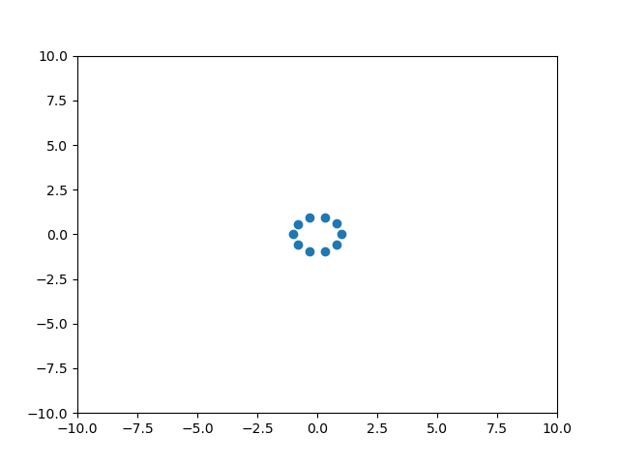
Figure 1. Image from our simulation, taken at time $t=0.$ The moon was modeled as a set of $N=10$ discrete point masses, each point possessing mass $m/10$ and charge $q/10.$
External Bodies: Earth and Sun
We treated the Earth and the Sun as external point masses. Their positions were determined from real-time ephemeris data from the Wolfram Data Repository.

We defined relative positions vectors $\vec{r_{12}}$ and $\vec{r_{13}}$ at each time step, representing the Earth-Moon and Sun-Moon separation vectors, respectively. All distances were then normalized by the Moon’s mean radius $R_{0}=1.7374×{10}^{6}\text{m},$ such that the lunar radius could be set to $1$ in the simulation.

The Earth’s mass $m_{12}$ was scaled to $1,$ while the Sun’s mass $m_{13}$ was scaled relative to Earth as $m_{13}=\frac{1.989×{10}^{30}}{5.972×{10}^{24}}≈3.33×{10}^{5}.$ Both bodies were assumed to be electrically neutral, so only their gravitational influences were implemented.

Force Model
The net force on body $i$ was calculated by:
$$\vec{F_{i}}=\sum_{j≠i}{\left(κ\frac{q_{i}q_{j}}{r_{ij}^{3}}⋅\vec{r_{ij}}\right)}-k_{a}\vec{r_{i,i+1}}-k_{c}\vec{r_{i,11}}-G\frac{{m_{i}m}_{12}}{r_{12}^{3}}⋅\vec{r_{12}}-G\frac{{m_{i}m}_{13}}{r_{13}^{3}}⋅\vec{r_{13}}.$$

with $\vec{r_{ij}}$ being the displacement vector from body $j$ to $i$, $\vec{r_{i,i+1}}$ being the displacement vector body $i$ and its neighbor, and $\vec{r_{i,11}}$ being the displacement vector from body $i$ to the geometric center.
The net acceleration was determined by dividing all terms by $m_{i}$. We also incorporated a damping term to model internal dissipation effects, proportional to velocity, governed by damping coefficient $d.$

Our resulting net acceleration equation on body $i$ was then:
$$\vec{a_{i}}=\sum_{j≠i}{\left(κ\frac{q_{i}q_{j}}{r_{ij}^{3}m_{i}}⋅\vec{r_{ij}}\right)}-\frac{k_{a}\vec{r_{i,i+1}}}{m_{i}}-\frac{k_{c}\vec{r_{i,11}}}{m_{i}}-G\frac{m_{12}}{r_{12}^{3}}⋅\vec{r_{12}}-G\frac{m_{13}}{r_{13}^{3}}⋅\vec{r_{13}}-d\left(v_{i}⋅\hat{r_{i,11}}\right)\hat{r_{i,11}}.$$

Nondimensionalization
We employed nondimensionalization to increase computational efficiency and isolate governing parameters.
For a variable $x,$ we define
$$x=x_{0}x^{*},$$with $x_{0}$ representing the characteristic scale and $x^{*}$ the nondimensionalized variable. The expression for the magnitude of gravitational acceleration on body $i$ becomes:$$G\frac{m_{12}}{r^{2}}+G\frac{m_{13}}{r^{2}}=\frac{G_{0}G^{*}M_{0}m_{12}^{*}}{L_{0}^{2}r^{*2}}+\frac{G_{0}G^{*}M_{0}m_{13}^{*}}{L_{0}^{2}r^{*2}}$$
We multiply this expression by $\frac{L_{0}^{2}}{G_{0}M_{0}}$ to obtain the nondimensionalized expression for gravitational acceleration:
$$\frac{L_{0}^{2}}{G_{0}M_{0}}⋅\left(\frac{G_{0}G^{*}M_{0}m_{12}^{*}}{L_{0}^{2}r^{*2}}+\frac{G_{0}G^{*}M_{0}m_{13}^{*}}{L_{0}^{2}r^{*2}}\right)=\frac{G^{*}m_{12}^{*}}{r^{*2}}+\frac{G^{*}m_{13}^{*}}{r^{*2}}$$
The expression for the magnitude of electrostatic acceleration becomes:
$$\sum_{j≠i}{κ\frac{q_{i}q_{j}}{r^{2}m_{i}}}=\sum_{j≠i}{\frac{κ_{0}κ^{*}q_{0}q_{i}^{*}q_{0}q_{j}^{*}}{L_{0}^{2}r^{*2}M_{0}m_{j}^{*}}.}$$
Multiplying by $\frac{L_{0}^{2}}{G_{0}M_{0}},$we get
$$\sum_{j≠i}{\frac{L_{0}^{2}}{G_{0}M_{0}}⋅\frac{κ_{0}κ^{*}q_{0}q_{i}^{*}q_{0}q_{j}^{*}}{L_{0}^{2}r^{*2}M_{0}m_{j}^{*}}}=\sum_{j≠i}{\frac{κ_{0}q_{0}^{2}}{G_{0}M_{0}^{2}}⋅\frac{κ^{*}q_{i}^{*}q_{j}^{*}}{r^{*2}m_{i}^{*}}}.$$
The magnitude of acceleration from $k_{a}$ spring forces becomes:
$$\frac{k_{a}r}{m_{i}}=\frac{k_{a0}k_{a}^{*}L_{0}r^{*}}{M_{0}m_{i}^{*}}.$$
Multiplying by $\frac{L_{0}^{2}}{G_{0}M_{0}},$ we get
$$\frac{L_{0}^{2}}{G_{0}M_{0}}⋅\frac{k_{a0}k_{a}^{*}L_{0}r^{*}}{M_{0}m_{i}^{*}}=\frac{k_{a0}L_{0}^{3}}{G_{0}M_{0}^{2}}⋅\frac{k_{a}^{*}r^{*}}{m_{i}^{*}}.$$
Similarly, the nondimensionalized form of the acceleration from $k_{c}$ spring forces is:
$$\frac{k_{c0}L_{0}^{3}}{G_{0}M_{0}^{2}}⋅\frac{k_{c}^{*}r^{*}}{m_{i}^{*}}.$$
Adding these expressions leads us to the net nondimensionalized acceleration:
$${a_{i}}^{*}=\frac{G^{*}m_{j}^{*}}{r^{*2}}+\frac{κ_{0}q_{0}^{2}}{G_{0}M_{0}^{2}}⋅\frac{κ^{*}q_{i}^{*}q_{j}^{*}}{r^{*2}m_{i}^{*}}+\frac{k_{a0}L_{0}^{3}}{G_{0}M_{0}^{2}}⋅\frac{k_{a}^{*}r^{*}}{m_{i}^{*}}+\frac{k_{c0}L_{0}^{3}}{G_{0}M_{0}^{2}}⋅\frac{k_{c}^{*}r^{*}}{m_{i}^{*}}.$$

We now define the following coefficients:
$$A=\frac{κ_{0}q_{0}^{2}}{G_{0}M_{0}^{2}} \\ B=\frac{k_{a0}L_{0}^{3}}{G_{0}M_{0}^{2}} \\ C=\frac{k_{c0}L_{0}^{3}}{G_{0}M_{0}^{2}}.$$

These coefficients govern the relative strength of the electrostatic, lateral spring, and radial spring forces, respectively.

Numerical Integration and Simulation Conditions
We employed the fourth-order Runge-Kutta method to our resulting system to approximate the trajectories of each point. Simulations were conducted using the following parameters:
- Number of points $N=10$
- Total time $T=100$
- Number of timesteps $N_{t}=10000$
- Initial angular velocity $ω_{0}=0.3$
- Damping factor $d=1$
- Spring relaxed length $l=0.$

- Results

Calculating the Real-World Values of the Nondimensionalized Coefficients
We first determined the nondimensionalized coefficients $A, B,$ and $C$which corresponded to real lunar parameters. Substituting the following constants into our equation for $A$, we calculated the electrostatic coefficient:
$$κ_{0}=8.99×{10}^{9} \\ q_{0}=6.776×{10}^{-3} \\ G_{0}=6.67×{10}^{-11} \\ M_{0}=5.972×{10}^{24},$$
yielding in a value of $A=1.74×{10}^{-34}$.

We then computed the combination of realistic values $B$ and $C$ which preserved the original circular structure, and the equilibrium radius of $1.$ The following coefficient values were obtained:
$$A=1.74×{10}^{-34} \\ B=2.64×{10}^{-5} \\ C=1.00×{10}^{-5}.$$
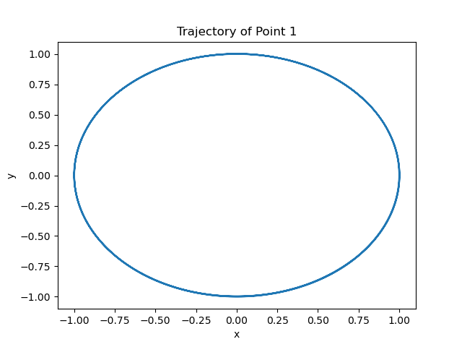
Figure 2. Visual representation of the orbital trajectory of a single surface point under the conditions $A=1.74×{10}^{-34}, B=2.64×{10}^{-5},$ and $C=1.00×{10}^{-5}$, resulting in an average radius of $r=0.999765823920226$ and average angular velocity of $ω=0.3000660600495767.$
The circular trajectory of a single surface point and the preservation of radius and angular velocity in Figure 2 confirms that the moon maintains its original shape and radius over time in this case. Our result validates that our model is able to replicate the Moon’s real-world stability when appropriately scaled.

Lateral Stiffness Dominates Structural Stability in the Model
We performed parameter sweeps for $A, B,$ and $C$ to examine how our system responded to different conditions. The average radius $r$was calculated in each iteration after a fixed duration of $T=100,$allowing us to quantify the relative impact of electrostatic, lateral spring, and radial spring forces on lunar deformation.

A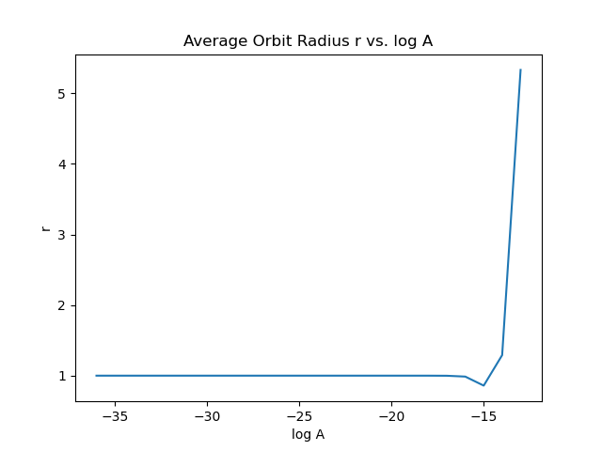 | B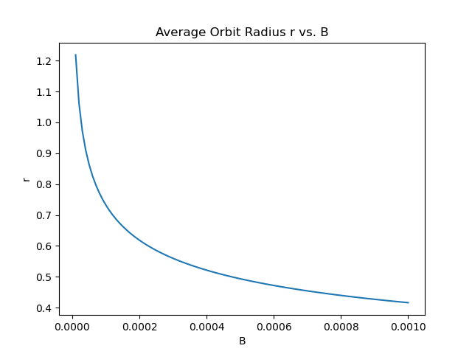 | C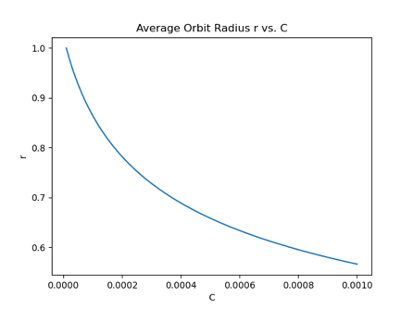
D | E | F

Figure 3. Quantifications of the effects of nondimensional force coefficients on average radius $r.$ Panels (A)-(C) show the system’s sensitivity to individual coefficients: (A) coefficient A (a logarithmic scale was used for the x-axis), (B) coefficient B, and (C) coefficient C. Additionally, contour plots were generated in panels (D)-(F) to examine the effects of pairs of parameters: (D) A and B, (E) A and C, and (F) B and C. Any coefficient not being varied was held constant at its real-world value defined in the section above.
As shown in Figure 3A, the coefficient $A$ only has a noticeable effect on $r$ when its value is as large as $≈{10}^{-15}.$ The horizontal contour lines in Figure 3D and 3E further confirm that $A$ minimally affects $r.$ As such, changes in the electrostatic strength exhibit virtually no effect on planet radius.

In contrast, increasing $B$ and $C$ results in a smaller radius. When $B$ increases, $r$ drops significantly, indicating substantial deformation. A similar result is exhibited when increasing $C,$ although with a more gradual slope, suggesting a comparatively small influence on planet shape. The slopes of the contour lines in Figure 3F are clearly $<<<-1,$ confirming the system is the most sensitive to changes in $B$.

Higher Stiffness Leads to Increased Average Angular Velocity
We performed additional parameter sweeps, where we calculated the average angular velocity $ω$
to examine the effect of these coefficients on the planet’s rotational dynamics.

A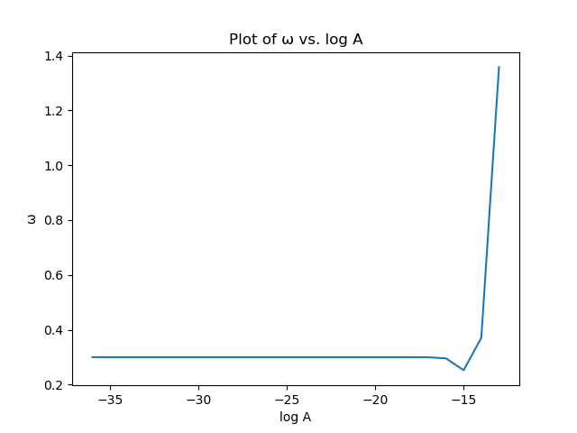 | B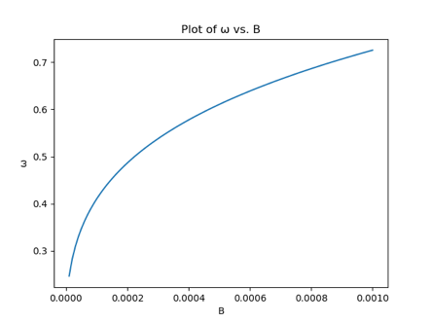 | C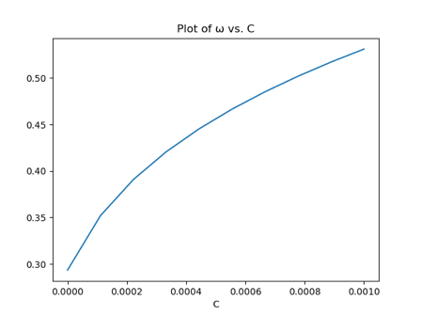

Figure 4. Quantifications of the effects of (A) A (a logarithmic scale was used for the x-axis), (B) B, and (C) C, on average angular velocity $ω,$ calculated by the formula $ω=\left|\vec{v}-\frac{\vec{v}⋅\vec{r}}{\vec{r}⋅\vec{r}}\vec{r}\right|.$ As before, any coefficient not being varied was held constant at its real-world value.
As shown in Figure 4, all coefficients were positively correlated with $ω.$ Consistent with the radius results, increasing $A$ only results in a noticeable effect on $ω$ when its value exceeds that of$≈{10}^{-15}.$ On the other hand, increases in $B$ and $C$ produce significant and sustained growth in $ω,$but with $B$ producing a steeper curve. We discern from examining these plots that lateral stiffness has the strongest effect on rotational dynamics, further confirming its dominant role in planet deformation.

Convergence to Stable Elliptical Geometry Despite Explosive Behavior Through Self-Stabilization
Our model expressed a strong ability for self-stabilization, even while subjected to extreme parameter configurations. The system may begin with significant deformation or “explosions” due to overly strong internal forces, but it does not disintegrate or collapse. The body instead morphs towards a more stable structural arrangement.

A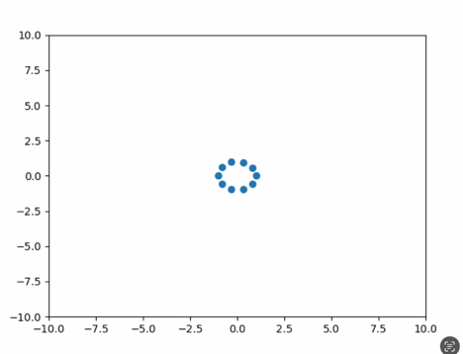 | B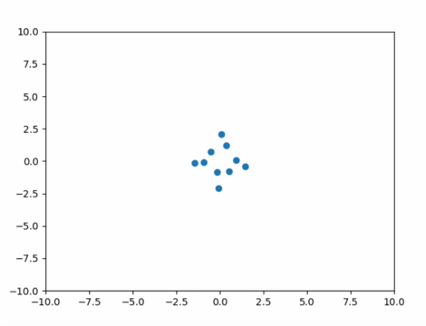 | C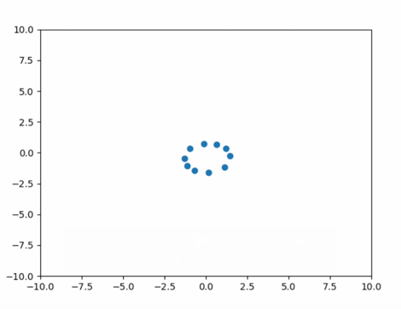
Figure 5. Images taken from three different stages during a simulation run, conducted with parameters $A=1.00×{10}^{-14},B=2.64×{10}^{-5},$ and $C=1.00×{10}^{-5}.$ (A) was taken during the initial state, (B) was taken during a moment of instability, and (C) was taken after self-stabilization, the final result a stable, elliptical structure.
Figure 5 depicts the evolution of the system from its initial state to its instable state to its final self-stabilized state. The simulation was run with extreme conditions ($A$ was magnified by a factor of order ${10}^{20}$ compared to its real-world value).

- Discussion

Insignificance of Electrostatic Forces Under Realistic Parameters
Our results from the parameter sweeps in Figure 3 indicate that the internal electrostatic forces of the Moon, represented by $A,$ contribute minimally to lunar deformation. Significant deviations in lunar radius are only observed when $A$ exceeds $≈{10}^{-15},$ a value nearly ${10}^{19}$ times its typical physical value ($A=1.74×{10}^{-34}).$ Under realistic astrophysical conditions, the Moon’s net charge has an indiscernible effect. Thus, we make the claim that electrostatic forces can be safely neglected in our Moon’s deformation models unless extreme charge accumulation occurs.

Unexpected Lateral Spring Force Sensitivity
Contrary to our initial expectations, coefficient $B$ exerted a stronger influence on the Moon’s structure than $C.$ Intuitively, one may anticipate that the radial spring forces would dominate structural dynamics; its directions directly pull towards the center, while the directions of the lateral spring forces are tangential and should not have much effect. However, our simulation results consistently reveal that lateral spring forces exert the largest effect on both radius and angular velocity. This phenomenon may reflect the limitations of our model discretization. With $N=10$ point masses, lateral spring influences may be amplified. We hypothesize that in simulations with higher values of $N$, radial stiffness may emerge as the dominant variable. Nevertheless, within the present framework, lateral spring interactions exert dominant control on lunar deformation.

Energy Redistribution
Additionally, our parameter sweeps in Figure 4 indicate that strengthening internal forces leads to increased angular velocity across all variables. This heightened angular motion may function as an energy redistribution mechanism. Internal forces conserve the total mechanical energy of the system (see Appendix). Therefore, any increase in their magnitude cannot create or destroy energy but is instead translated into rotational motion.

Implications of the Self-Stabilization Mechanism
Our system consistently evolved towards a stable elliptical configuration, despite any explosions or severe deformation. This phenomenon is most likely observed due to internal damping, which dissipates excess energy, and the effect of elastic forces, ultimately approaching a minimum-energy configuration. The presence of this self-stabilization implies that a system influenced by gravitational, electrostatic, elastic forces, and internal damping can recover from extreme structural disturbances without external intervention. Analytical work using energy-based methods, such as Lyapunov stability analysis or energy landscape modeling, may be conducted to characterize such deformation in future investigations.

Pathways for Model Extensions
Our presented model has the ability to predict the fundamental dynamics of lunar deformation. However, several extensions could be implemented to enhance its realism and applicability. Our model represents the Moon as having only one layer of mass, but the physical structure is not hollow. A natural extension is to incorporate multiple layers of mass to better simulate the characteristics of real celestial bodies. Another promising direction is to develop our model into a three-dimensional simulation that accounts for depth in the Z-axis. Furthermore, celestial bodies are rarely perfectly spherical. Incorporating triaxial ellipsoid geometries into our simulation, as in recent exoplanet studies (Akinsanmi et al., 2019), could capture pre-existing or tidally induced asphericities. Finally, implementing the gravitational influence of a third external body, namely Jupiter, could provide a more precise model of lunar deformation. Together, these features would enhance the model's realism and increase its applicability to a wider range of astrophysical scenarios.

- Conclusion
Our simulations indicate that electrostatic forces have minimal impact on lunar deformation under physically realistic parameters. They also reveal that lateral spring forces dominate over radial, gravitational, and electrostatic forces in inducing structural changes. Finally, our model’s ability to self-stabilize regardless of extreme perturbations demonstrates that the Moon’s structure has a high level of resilience.

The modeling framework we developed in this study is not limited to the Moon. It becomes a versatile tool for probing the deformation of any planetary body. Through our successful development of a model that captures the interplay between elasticity, gravity, and electrostatics, this work advances us toward a physics-based theory of planetary structural stability.

- Appendix

Here, we prove that the total mechanical energy of the system is conserved under the internal forces defined in the Methods section. We also show that energy is not conserved when external forces are introduced.

Electrostatic Forces
We begin by calculating the time derivatives of kinetic and potential energy. We use the equation
$$\frac{dK_{i}}{dt}=\vec{F_{i}}⋅\vec{v_{i}}$$
where $F_{i}$ is the net gravitational force and $v_{i}$ is the velocity of an arbitrary point $i$. We know that
$$F_{i}=\sum_{j≠i}{κ\frac{q_{i}q_{j}}{r_{ij}^{2}}},$$
where $κ$ is the Coulomb constant and $r_{ij}$ is the distance between the two distinct points $i$ and $j.$
We can write this as a vector
$$\vec{F_{i}}=-\sum_{j≠i}{κ\frac{q_{i}q_{j}}{r_{ij}^{3}}}⋅\vec{r_{ij}}$$
where $\vec{r_{ij}}$ is the vector from point $j$ to $i$. Let $\left(x_{i},y_{i}\right)$ be the position of point $i$ and $\left(x_{j},y_{j}\right)$ be the position of point $j.$ We can rewrite our vector as
$$\vec{F_{i}}=-\sum_{j≠i}{κ\frac{q_{i}q_{j}}{r_{ij}^{3}}}⋅\left({x_{i}-x_{j} \atop y_{i}-y_{j}}\right).$$
We can now calculate
$$\frac{dK_{i}}{dt}=\vec{F_{i}}⋅\vec{v_{i}}=-\sum_{j≠i}{\left(κ\frac{q_{i}q_{j}}{r_{ij}^{3}}⋅\left({x_{i}-x_{j} \atop y_{i}-y_{j}}\right)\right)}⋅\left({dx_{i}/dt \atop dy_{i}/dt}\right).$$
Let us now calculate the rate of change of the gravitational potential energy of the system. We use the equation
$$\frac{dU_{i}}{dt}=\sum_{j≠i}{\frac{d}{dt}\left(-κ\frac{q_{i}q_{j}}{r_{ij}}\right)}=\sum_{j≠i}{κ\frac{q_{i}q_{j}}{r_{ij}^{2}}}⋅\frac{dr_{ij}}{dt}.$$
By the chain rule,
$$\frac{dr_{ij}}{dt}=\frac{∂r_{ij}}{∂x_{i}} \frac{dx_{i}}{dt} +\frac{∂r_{ij}}{∂y_{i}} \frac{dy_{i}}{dt}.$$
We also know that $r_{ij}=\sqrt{{\left(x_{i}-x_{j}\right)}^{2}+{\left(y_{i}-y_{j}\right)}^{2}}.$ From here, we can find
$$\frac{∂r_{ij}}{∂x_{i}} =\frac{x_{i}-x_{j}}{r_{ij}}, \frac{∂r_{ij}}{∂y_{i}} =\frac{y_{i}-y_{j}}{r_{ij}}.$$
Substituting, we get $\frac{dr_{ij}}{dt}= \frac{x_{i}-x_{j}}{r_{ij}} \frac{dx_{i}}{dt}+\frac{y_{i}-y_{j}}{r_{ij}} \frac{dy_{i}}{dt}.$
Writing this in vector notation, we get the following expression:
$$\frac{dr_{ij}}{dt}=\frac{1}{r_{ij}}\left({x_{i}-x_{j} \atop y_{i}-y_{j}}\right)⋅\left({dx_{i}/dt \atop dy_{i}/dt}\right).$$
Substituting this into our expression for $\frac{dU_{i}}{dt}$ we get
$$\frac{dU_{i}}{dt}=\sum_{j≠i}{\left(κ\frac{q_{i}q_{j}}{r_{ij}^{3}}⋅\left({x_{i}-x_{j} \atop y_{i}-y_{j}}\right)\right)}⋅\left({dx_{i}/dt \atop dy_{i}/dt}\right)=-\frac{dK_{i}}{dt}.$$
We can clearly see that $\frac{dK_{i}}{dt}+\frac{dU_{i}}{dt}=0,$
meaning that the total energy of the system is conserved under gravitational interactions.

Hooke’s Law Energy, $k_{a}$
Hooke's Law tells us that
$$\vec{F_{i}}=-k_{a}\vec{r_{i,i+1}},$$
where $k_{a}$ is the spring constant between the outer point masses.
The rate of change of kinetic energy is then
$$\frac{dK_{i}}{dt}=\vec{F_{i}}⋅\vec{v_{i}}=-k_{a}\vec{r_{i,i+1}}⋅\vec{v_{i}}.$$
The potential energy of a spring is defined by the equation
$$U_{i}=\frac{1}{2}k_{a}\vec{{r_{i,i+1}}^{2}}.$$
We differentiate to find the rate of change of potential energy:
$$\frac{dU_{i}}{dt}=k_{a}\vec{r_{i,i+1}}⋅\frac{d\vec{r_{i,i+1}}}{dt}=k_{a}\vec{r_{i,i+1}}⋅\vec{v_{i}}=-\frac{dK_{i}}{dt}.$$
Thus, we have shown that
$$\frac{dK_{i}}{dt}+\frac{dU_{i}}{dt}=0,$$
meaning that the total energy of the system is conserved under $k_{a}$ spring force interactions.

Hooke’s Law Energy, $k_{c}$
We can use a similar process to prove the same statement for $k_{c}$ spring forces.
We have
$$\vec{F_{i}}=-k_{c}\vec{r_{i,11}},$$
where $k_{c}$is the spring constant between the outer point masses and the origin.
Since the vector $\vec{r_{i,i+1}}$ has no particular computational significance in our proof for the $k_{a}$ case, we can replace it with $\vec{r_{i,11}}$ and carry out the proof in the same manner we did previously to show that the total energy of the system is also conserved under $k_{c}$ spring force interactions.

External Forces
The rate of change of kinetic energy is given by:
$$\frac{dK_{i}}{dt}=G\frac{m_{i}M_{12}}{r_{i,12}^{3}}\left({x_{i}-x_{12} \atop y_{i}-y_{12}}\right)⋅\left({dx_{i}/dt \atop dy_{i}/dt}\right)+G\frac{m_{i}M_{13}}{r_{i,13}^{3}}\left({x_{i}-x_{13} \atop y_{i}-y_{13}}\right)⋅\left({dx_{i}/dt \atop dy_{i}/dt}\right),$$where $\left(x_{12},y_{12}\right)$is the position of the Earth and $\left(x_{13},y_{13}\right)$ is the position of the Sun.
But unlike internal forces, there is no potential energy change due to external forces, so $\frac{dU}{dt}=0.$ As such,
$$\frac{dK_{i}}{dt}+\frac{dU_{i}}{dt}=\frac{dK_{i}}{dt}≠0,$$
meaning that the total energy of the system is not conserved under external forces.

Net Energy Equation
Now, we combine the expressions for the change of kinetic energy and potential energy due to each of the forces to find the net energy equation:
$$\frac{dK_{i}}{dt}=\sum_{j≠i}{\left(κ\frac{q_{i}q_{j}}{r_{ij}^{3}}⋅\vec{r_{ij}}\right)} \\ +\left(-k_{a}\vec{r_{i,i+1}}-k_{a}\vec{r_{i,i-1}}-k_{c}\vec{r_{i,11}}-G\frac{m_{i}m_{12}}{r_{i,12}^{3}}⋅\vec{r_{i,12}}-G\frac{m_{i}m_{13}}{r_{i,13}^{3}}⋅\vec{r_{i,13}}\right)⋅\frac{d\vec{x_{i}}}{dt}$$

$$\frac{dU_{i}}{dt}=-\sum_{j≠i}{\left(κ\frac{q_{i}q_{j}}{r_{ij}^{3}}⋅\vec{r_{ij}}\right)}+\left(-k_{a}\vec{r_{i,i+1}}-k_{a}\vec{r_{i,i-1}}-k_{c}\vec{r_{i,11}}\right)⋅\frac{d\vec{x_{i}}}{dt}$$
Adding these two equations gives us an expression for the change in mechanical energy for body $i$:
$$\frac{dE_{i}}{dt}=\frac{dK_{i}}{dt}+\frac{dU_{i}}{dt}=\left(-G\frac{m_{i}m_{12}}{r_{i,12}^{3}}⋅\vec{r_{i,12}}-G\frac{m_{i}m_{13}}{r_{i,13}^{3}}⋅\vec{r_{i,13}}⋅\right)⋅\frac{d\vec{x_{i}}}{dt}$$
We can now calculate the total change in mechanical energy of our system by summing throughout the $N$ bodies:
$$\frac{dE}{dt}=\sum_{i}^{N}{\left(-G\frac{m_{i}m_{12}}{r_{i,12}^{3}}⋅\vec{r_{i,12}}-G\frac{m_{i}m_{13}}{r_{i,13}^{3}}⋅\vec{r_{i,12}}\right)}⋅\frac{d\vec{x_{i}}}{dt}≠0.$$

Thus, only external forces are capable of causing changes in the mechanical energy of the system.

- References

- Akinsanmi, B., Barros, S. C. C., Santos, N. C., Correia, A. C. M., Maxted, P. F. L., Boué, G., & Laskar, J. (2019). Detectability of shape deformation in short-period exoplanets. Astronomy & Astrophysics, 621, A117. https://doi.org/10.1051/0004-6361/201834215
- Gu, I., Xu, A., Temur, D., Liu, I., & Ganesan, S. (2025, February 11). Modeling the dynamics of earth-moon-sun system through the 3-body-problem. Wolfram Community. Retrieved June 5, 2025, from https://community.wolfram.com/groups/-/m/t/3391505
- Halekas, J. S., Mitchell, D. L., Lin, R. P., Hood, L. L., Acuña, M. H., & Binder, A. B. (2002). Evidence for negative charging of the lunar surface in shadow. Geophysical Research Letters, 29(10). https://doi.org/10.1029/2001gl014428
- Kim, J. (2021, January 27). Modeling the Tidal Locking Mechanism of the Moon in Function of Inverse-Square Law and Hooke's Law [Paper presentation]. 2021 IEEE 11th Annual Computing and Communication Workshop and Conference (CCWC). https://doi.org/10.1109/CCWC51732.2021.9375846

